GA State Organization
2017 Leadership Institute
Features
Cathy P. Daugherty
2016 DKG Achievement Award Recipient
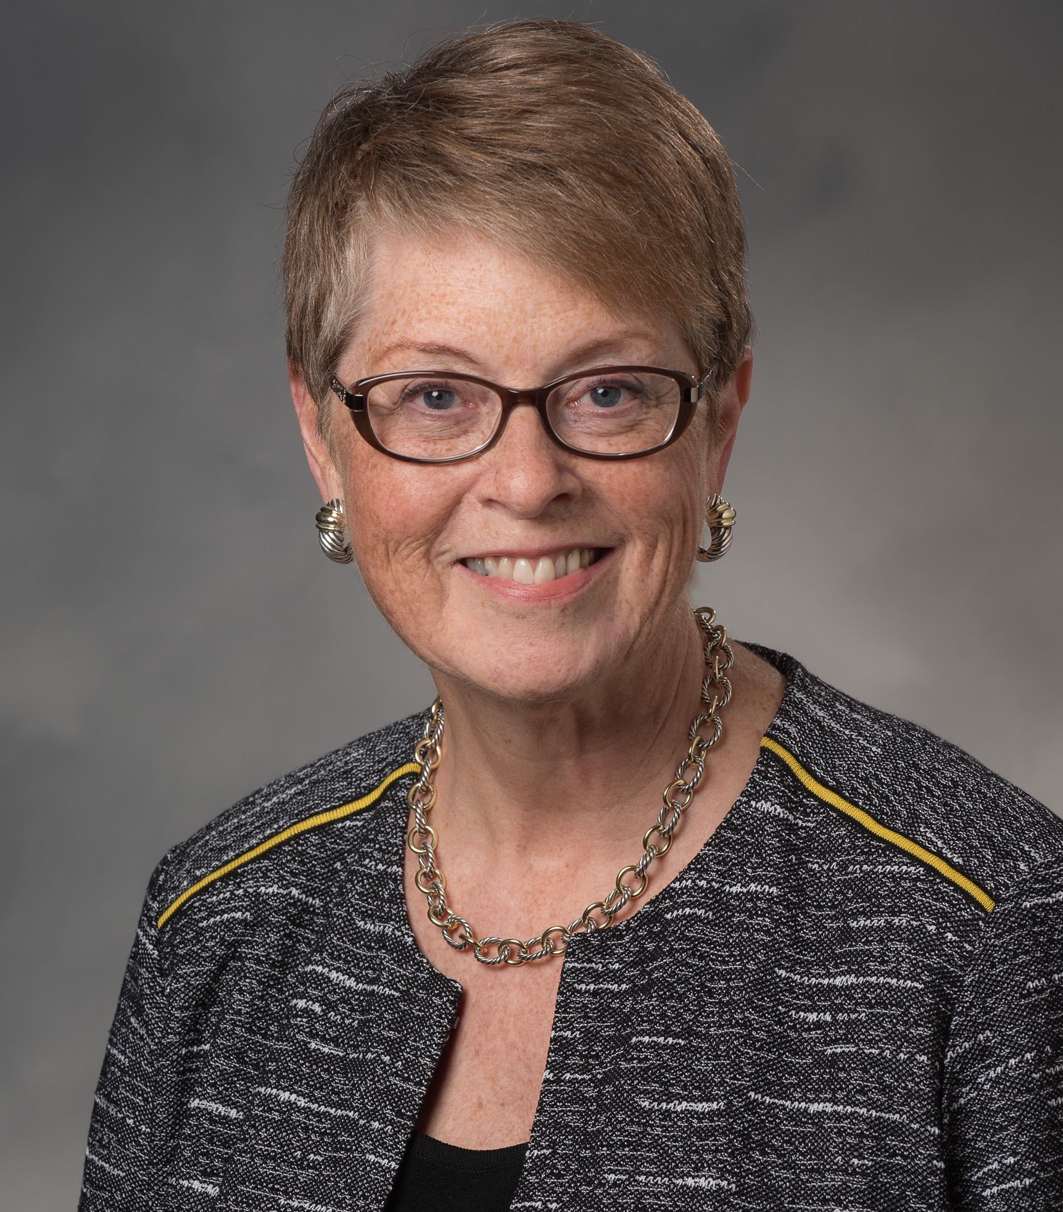

“Sharing my views on leadership and the opportunities for personal and professional growth through serving our Society is a message I love to share with DKG members,” said Cathy Daugherty when when accepting her invitation to be guest speaker at the 2017 Georgia State Organization Leadership Institute on Saturday, March 18. Daugherty, 2016 DKG Achievement Award recipient and current chair of the 2016-2018 Constitution Committee, actively serves at all levels of the Society and is a frequent presenter, trainer, and Society representative since becoming a member of Alpha Alpha Chapter (VA) in 1988.

A love of teaching at all levels has motivated Cathy’s professional life. Her forty-four year career in education included instruction in Latin, English and journalism, ranging from middle school through college. From 1987-1997 she taught Latin on television for the Virginia Satellite Educational Network (VSEN), making her an early proponent of distance learning to address discrepancies in course offerings across the nation. She also served in leadership roles in state and national classics organizations throughout her career, earning an Ovatio in 1997, the highest award given by CAMWS, the Classical Association of the Middle West and South. Before retiring from public school teaching in 2007, Cathy held the position of world language specialist for the Hanover County Public Schools. She recently retired as Adjunct Professor of Latin at Randolph-Macon College in Ashland, VA.

Service leadership opportunities mark Cathy’s work in DKG. Cathy is a graduate of the 1997 Leadership Management Seminar. She has served her state organization as president, editor, and executive secretary and is currently the parliamentarian. She has served on the Administrative Board twice, once in 2008-2010 when she was SE Regional Director and most recently as the Society’s 2014-2016 International First Vice-President. Along the way Cathy has been a trustee on the DKGEF Board, a NGO/ECOSOC representative to the United Nations and chair of the Administrative Board’s committees on strategic planning, EEC reorganization, and membership. Perhaps Cathy is best known to DKG members as chair of the the 2008-2010 Administrative Board sub-committee charged with proposing the Society’s first international project. She was point-person for the Schools for Africa project, authoring all issues of the SFA Newsette and is currently updating those issues for use by chapters and state organization across the Society.

Recreation for Cathy centers on renovation and landscaping of a 100-year old school property that she and her soon to retire husband, a RMC Professor of Classics, purchased 35 years ago when they married. She is active in local women’s groups and maintains active membership in classics organizations throughout the United States. As guest speaker for the 2017 GA Leadership Institute, Cathy said, “I hope to inspire the GA participants to seek opportunities to lead in their classrooms, the Society and their personal lives. Leadership is definitely NOT about the position you hold or where you sit in a meeting. It’s the mindset you display in whatever you do!”
Forest Hills United Methodist Church
1217 Forest Hill Road
Macon, GA 31210

Saturday, March 18, 2017
9:00 AM Registration
9:30 AM – 3:30 PM Program

$25.00 (includes catered lunch)

Please invite any colleagues or prospective members to attend with you.

Registration Information
DEADLINE March 10, 2017
(Mail this with check to Jonnie Ghetti, 1231 Branch Creek Way, Greensboro, GA 30642)

Name: __________

I agree that DKG may use photographs of me with or without my
name for any lawful purpose, including but not limited to the
purposes of publicity, illustration, advertising and Web content.

Signature of participant: _______________________________________
Email for confirmation: ___________
Cell Phone for confirmation: _________

